MADHAV INSTITUTE OF TECHNOLOGY AND SCIENCE, GWALIOR

SUBMITTED BY-

ASMITA JAIN

0901EO201017

SUBMITTED TO-

PROF. APRAJITA KUMARI

**SENSOR TECHNOLOGY LAB 220202**

**EXPERIMENT - 5**

**AIM:**

To study about the Air Pressure Sensor.

**THEORY:**TYPES OF AIR PRESSURE SENSOR:

1. Absolute air pressure sensor
2. Gauge air pressure sensor
3. Differential air pressure sensor

RESISTIVE AIR PRESSURE TRANSDUCER:

Working principle:

The pressure sensor converts the mechanical pressure value into a proportional electrical signal. The pressure sensor typically consists of a stable main body and a (thin) diaphragm. The diaphragm is the most important element for the measurement of the pressure and is equipped with strain-sensitive and compression-sensitive resistance structures, so-called strain gauges (DMS). The diaphragm is deflected under the influence of pressure.

Working:

The diaphragm, in contact with the air whose pressure is being measured, deforms as pressure increases, strain gauges attached to the non-contacting surface of the diaphragm are similarly deformed. The piezoresistive effect, in which the strain gauge material’s resistance alters when deformed, is converted into an electrical signal.

**CIRCUIT DIAGRAM:**

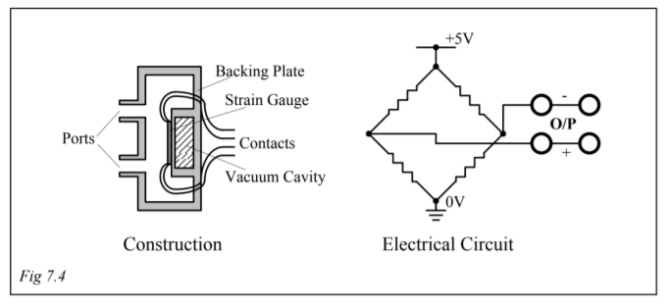

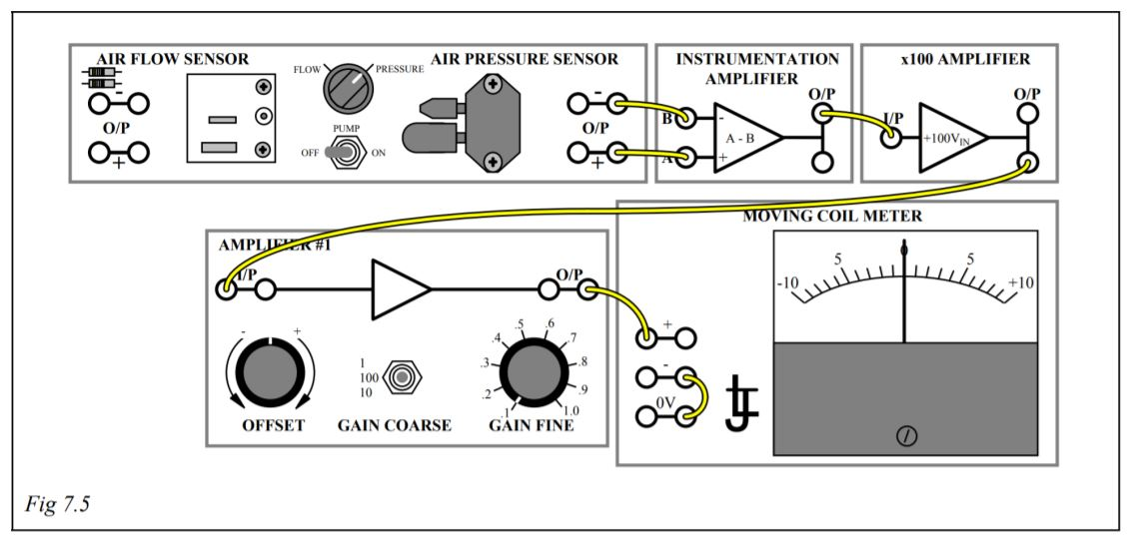

**OBERSERVATION TABLE:**

|  |  |
| --- | --- |
| Output voltage – Pump off | Output voltage – Pump on |
| 0 V | 4 V |

**RESULT:**

Hence, verified the principle of air pressure sensor.